“How does the number of bedrooms and bathrooms affect property prices?”

**Insight Extraction**

1. **Bedrooms vs. Price**
2. **Bathrooms vs. Price**

**Code for Analysis and Visualization**

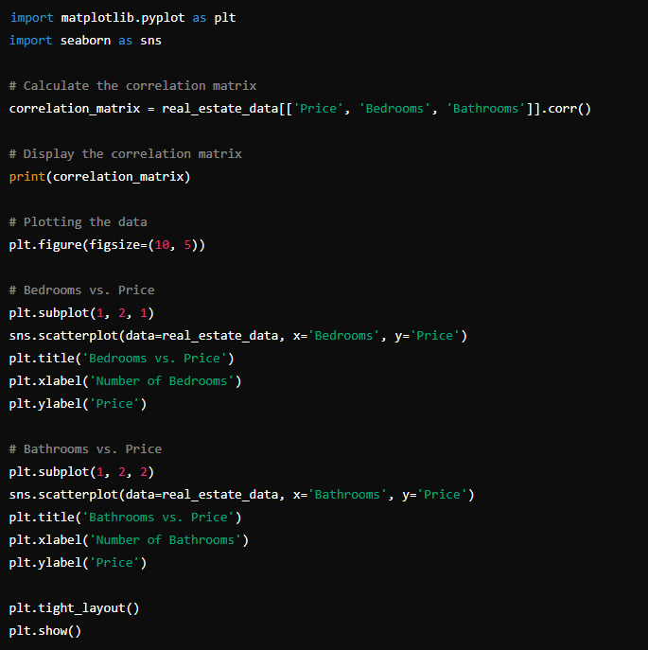

**Interpretation**

* If there is a high correlation (close to 1 or -1) between Price and Bedrooms or Bathrooms, it suggests a strong linear relationship.
* If the correlation is low (close to 0), it indicates a weak relationship.

**Correlation Analysis**

The correlation matrix is as follows:

|  | **Price** | **Bedrooms** | **Bathrooms** |
| --- | --- | --- | --- |
| **Price** | 1.0000 | 0.4863 | 0.4521 |
| **Bedrooms** | 0.4863 | 1.0000 | 0.5261 |
| **Bathrooms** | 0.4521 | 0.5261 | 1.0000 |

**Insights**

* **Bedrooms vs. Price:** There is a moderate positive correlation (0.4863) between the number of bedrooms and the price. This suggests that properties with more bedrooms tend to be more expensive, but the relationship is not very strong.
* **Bathrooms vs. Price:** There is a moderate positive correlation (0.4521) between the number of bathrooms and the price. Similar to bedrooms, properties with more bathrooms tend to be more expensive, but the relationship is also not very strong.

**Graphs Interpretation**

* The scatter plots show a general trend where prices increase with the number of bedrooms and bathrooms, but there is a significant amount of variability.

**Suggestion for other factor:**

Since the correlations are moderate, it indicates that other factors may also significantly influence the price.

>> As a real estate agent experience, my gut feeling or instinct that affect the price of the property would be a few things affect the price most:

* **Property size**.
* **Property type**
* **Age of the property**
* **Location-specific factors:** how close to the amenities, schools, and public transport. (does not cover in this project)

>> I will let our team members provide deeper insight into the other factors.